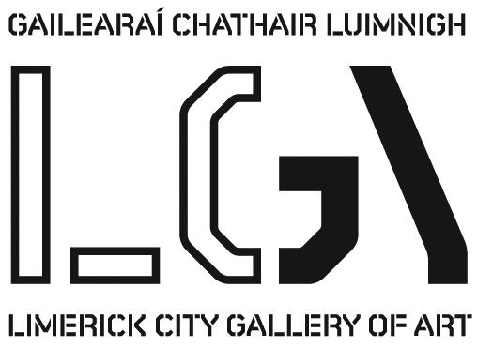
Collecting and Curating | Limerick City’s Art 1935 – 2014

Visitors to the Limerick City Gallery often ask how its collection was formed and the present exhibition is an attempt to answer that. It originated in 1936 when a group of citizens started the Limerick Art Gallery Committee with the aim of building a collection that might one day find a permanent home in the city. It gained the support of the president of the Royal Hibernian Academy, Dermod O’Brien, who encouraged his peers to present a work, while private citizens gave many more. By 1948, when the room in which the present exhibition is held had been added to the Carnegie Library and Museum as a dedicated gallery, approximately 200 works had been acquired. Having achieved its goal, the Committee transferred its collection to the ownership of the city and it then disbanded.

In the years that followed works were added through gifts and bequests and, increasingly, from cultural foundations such as the Irish Hospitals Trust, the Thomas Haverty Trust, the Friends of the National Collections, and the Arts Council. Since 1977 the Gallery has provided a space for EVA, the city’s principal contemporary exhibition, thereby providing a stimulus for further significant acquisitions. A major boost came in 1987 when a voluntary group, Limerick Contemporary Art, donated over one hundred drawings to form the basis of the National Contemporary Drawing Collection. The largest single bequest came in 1987 with almost 2,000 examples of the art of the poster, assembled by Michael O’Connor, a Listowel businessman.

From its foundation the Gallery had functioned without a director, its policies determined by an advisory committee appointed by Limerick Corporation. In 1984 the Arts Council offered to increase its financial support if the Gallery were extended and a full-time director appointed. Thus the appointment of Paul O’Reilly as director in 1985 marked a significant break with the past. During his fifteen-year tenure a conservation programme commenced and the capacity of the Gallery to acquire new work increased significantly. Those policies were developed further by his successors; Mike Fitzpatrick (2001), Pippa Little (2009), Marion Lovett (2010) and Helen Carey (2012).

John Logan
27 November 2014

Exhibition runs 28th November 2014 to 8th January 2015

For further information please contact artgallery@limerick.ie Tel: 061 310633

Opening Hours: Monday- Friday 10-5.30, Thursday 10-8.30; Saturday 10-5pm & Sunday 12-5pm
Closed on Bank Holidays
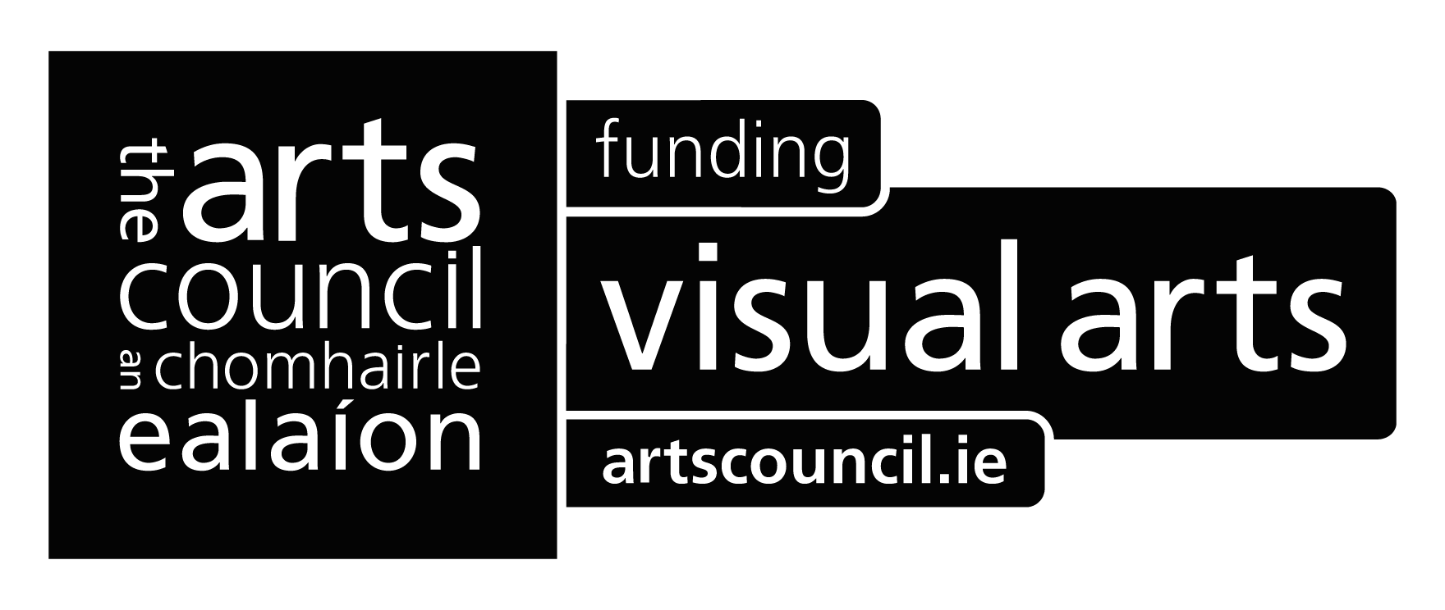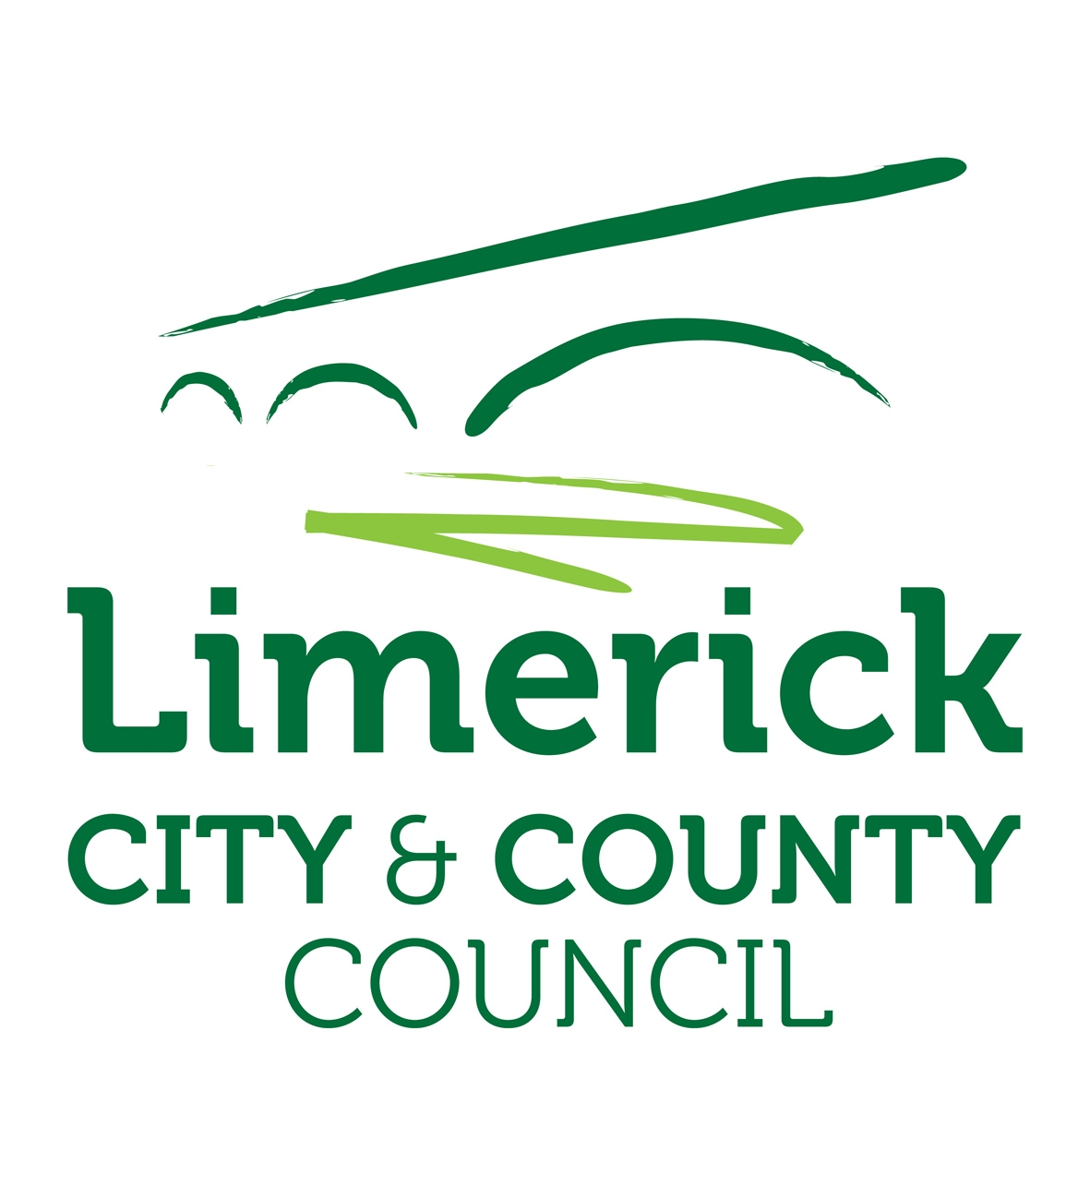
Selected artworks on exhibit
Jeremiah Hodges Mulcahy, Landscape with Lake, c. 1840,
oil on linen, 44 x 60, Gift of Stephen O'Mara, 1948

Jeremiah Hodges Mulcahy, Landscape with Waterfall, c. 1840
oil on linen, 73 x 51, Gift of Stephen O’Mara, 1948

Jeremiah Hodges Mulcahy, Curragh Chase, 1834
oil on linen, 60.8 x 75, Gift of Limerick Art Gallery Committee, 1948

Sean Keating, Daoine Simplidhe (Simple Folk) 1937
oil on linen, 101 x 121, Gift of the artist, 1948

Wiliam Orpen, Man of the West (Seán Keating), 1915
oil on linen, 96 x 106, Gift of the Irish Hospitals Trust, 1948

Maurice Mac Gonigal, A Dublin Studio (Metropolitan School of Art)
oil on linen, 101 x 121, Gift of the artist, 1951

William John Leech. Fields by the Sea, 1954
oil on linen, 44.5 x 53, Gift of Richard Irvine Best, 1959

Camille Souter, Washing by the Canal, 1964
acrylic on panel, 58 x 79, Gift of the Thomas Haverty Trust, 1965

James Sinton Slater, Kate O’Brien, 1959
oil on linen, 81 x 60,Gift of Kate O’Brien, 1965

Charles Harper, Living Units - (visit B), 1984
oil on canvas, 152 x 152 , On permanent loan from the Arts Council of Ireland, 1987

Selected works from the Michael O’Connor Poster Collection donated in 1988/89,

Amelia Stein with Cindy Cummins, Untitled, 1993
four black and white photographs, 80 x 75 , Purchased at ev+a, 1993

Martin Yelverton, Culhanes’ Old House Boreen, 1985
oil on board, 25 x 18, Gift of Rudi Fuchs, adjudicator, ev+a, 1986

Robert Carver, Landscape, c. 1754
oil on linen, 125x156.5 cm (unframed), Gift of Limerick Art Gallery Committee, 1948
Conserved and restored by funds from the Open Award made by Germano Celant, adjudicator, ev+a, 1991

Alice Maher, Sleep
Etching, 19 x 26.5, Purchased at Green on Red Gallery, 1997

Alice Maher, Rain
Etching, 19 x 26.5, Purchased at Green on Red Gallery, 1997

Alice Maher
Talking to my Hair
Etching, 20 x 26, Purchased at Green on Red Gallery, 1997

Alice Maher, Dancer
Etching, 19 x 26.5, Purchased at Green on Red Gallery, 1997

Willie Doherty, Evergreen Memories, 1988
triptych of black and while photographs, 102 x 176, Purchased at Oliver Dowling Gallery, 1989

Robert Ryan, Mother and Young, 2009
oil on board, 9 x 11 , Purchased at Limerick Printmakers, 2010

Robert Ryan, The Forest Singer, 2009
oil on board, 9 x 11, Purchased at Limerick Printmakers, 2010

Robert Ryan, Song Bird, 2009
Oil on board, 9 x 11 cm (unframed), Purchased at Limerick Printmakers, 2010

Michael Warren, Her Hair (2), 1993
burnt oak, 155 x 40 x 20 , Purchased with the aid of the Arts Council, 1993

Samuel Walsh, Drawing 118, 1987
charcoal and conte on paper, 61 x 84.5, Gift of Limerick Contemporary Art Society for
National Collection of Contemporary Drawing, 1991

Donald Teskey, Blue Cromwell Point III, 1995
oil on canvas, 132 x 152, Purchased from the artist, 1996

Jack Donovan, Kitty and Eddie, undated
conte on paper, 30 x 22.5, Gift of Kitty Bredin to Limerick Contemporary Art Society for
National Collection of Contemporary Drawing, 1991

Don MacGabhann, Tarraingt, 1997
pencil on paper, 110 x 37, Gift of Limerick Contemporary Art Society for
National Collection of Contemporary Drawing, 1997

David Nash, Running Tables numbers 1,2,3, 1982
Wood, 30 x 58.5 x 23, Gift of the Friends of the National Collections of Ireland, 1983

Cormac Boydell, Garden, 1993
Ceramic, 39 x 39, Purchased from the artist 1995

Jerome Connor, Æ George Russell, 1928
Bronze, 56 x 46 x 36 , Gift of Limerick Art Gallery Committee, 1948

Jerome Connor, Young Woman, 1934
Bronze, 12.5 x 13 x 6, Gift of Limerick Art Gallery Committee, 1948

Walter Verling, Sky II,
oil on board, 40 x 48.5, Purchased from the artist, 1999

Patrick Hennessy, View of Kinsale, 1940
Oil on linen, 20 x 15, Gift of Limerick Art Gallery Committee, 1948

Gavin Hogg, Trinity, 1997
Oil on wax on board, 61 x 61, Purchased from the artist, 1997

For further information please contact artgallery@limerick.ie Tel: 061 310633

Opening Hours: Monday- Friday 10-5.30, Thursday 10-8.30; Saturday 10-5pm & Sunday 12-5pm
Closed on Bank Holidays

